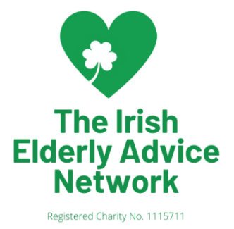

Irish Elderly Advice Network

Volunteer Application Form

Thank you very much for your interest in volunteering for Irish Elderly Advice Network. If you need assistance with completing this form, please email us at volunteering@irishelders.org.uk

All the information you provide on this form is confidential and will not be passed on to a third party. Irish Elderly Advice Network complies fully with Current Data Protection and Freedom of Information legislation.

Which volunteer role are you applying for?

How did you hear about this role?

Please tell us about yourself

Title |  | Forename(s)
Surname

Address

Post code

Telephone
Email
Where born (county if born in Ireland)
Emergency contact:
(Name, relationship to you & contact number)
Please select which method(s) you would prefer for contacting you about your volunteer application | Phone Text  x  Email Letter

Please tell us why you would like to volunteer for Irish Elderly Advice Network (you can tick more than one box)

I want to help end loneliness |  | I’m interested in meeting new people
To make myself more employable |  | Sharing my skills and experience to help others
Give something back in my community |  | I want to develop new skills
To keep myself busy |  | Something enjoyable to do with my time
I was asked by a friend |  | I want to make a difference
To help me in my journey |  | I believe in this cause
Any other reason:

Please tell us a little more about you and what skills and qualities you feel make you suitable for this volunteer role (Please refer to the volunteer description, in particular the skills and experience required for the role)

Your availability to volunteer

Which days/ times are you available to volunteer? (Please note not all volunteer roles are available at all these times) Please tick all that apply. If the role does not take place at regular times, please leave blank and discuss with your volunteer co-ordinator.

 | Mon | Tue | Wed | Thu | Fri | Sat | Sun
Morning
Afternoon
Evening

Volunteering status

The right to volunteer in the UK can be dependent on your citizenship and UK immigration status so please make sure that you are allowed to volunteer on your visa.

Are you legally entitled to stay in the UK? Y/N

References

Please provide us with the details of two people whom we may contact as referees, to comment on your suitability for volunteering. These can be friends or colleagues but not family members, and must have known you for six months or more.

 | Referee 1 | Referee 2
Name

Email

Telephone

What is your relationship to this person?

Medical Conditions

Do you have any medical conditions you would like us to be aware of?

Yes No

If yes, please tell us about it. Tell us what we should do If there is an emergency and if you need help.

Do you have any other support needs?

Yes No
If yes, please tell us about it so we can support you.

Keeping you informed about the work of Irish Elderly Advice Network

We would like to keep you informed about our work, fundraising and other activities, please tick the boxes if you are happy to hear from us

Email Phone Post

Data Protection.

We follow the Data Protection rules. Data Protection rules means you have to follow strict rules when using someone’s personal information. All the personal information you give to us will be kept safe and will only be seen by the volunteering team and the volunteer Manager. We will keep your information for 7 years.

Declaration

I declare that the information given in this application is a true and complete statement. I understand that any offer of appointment and subsequent volunteering is subject to satisfactory references and satisfactory disclosure from the Disclosure and Barring Service or Disclosure Scotland at the appropriate level, where this is a requirement of the role (if stated in the volunteer role description).

Signature: Date:

